PGII Z • 1537 S Higley Rel, Gil bc1 l AZ !>1 % -4-1 71

**BUTTI, PRATHYUSHA (id #485733, dob: 10/12/1989)**

Recipient:

US Consulate General

Paigah Palace

1-8-323, Chiran Fort Lane

Begumpet, Secunderabad - 500003

Date: 09/08/2021

RE: Pralhyusha Butti, DOB: 10/12/1989, PT ID #485733

I am the **treating OB/GYN** for **Prathyusha Butti.**

This letter confirms that Prathyusha Butti is pregnant, and her expected due date is 25th November 2021.

**Prathyusha Butti** is now pregnant at 30 weeks and her pregnancy is classified to be high risk as she has uterine fibroids leading to fetal growth restriction due to which she requires weekly sonograms to monitor her health. She is additionally being monitored by fetal maternal specialist as we anticipate a preterm delivery. She is recommended to take extreme care of her health and follow a very strict diet at this time. It is recommended to have her parents support at this time and also in post-partum recovery.

Sincerely,

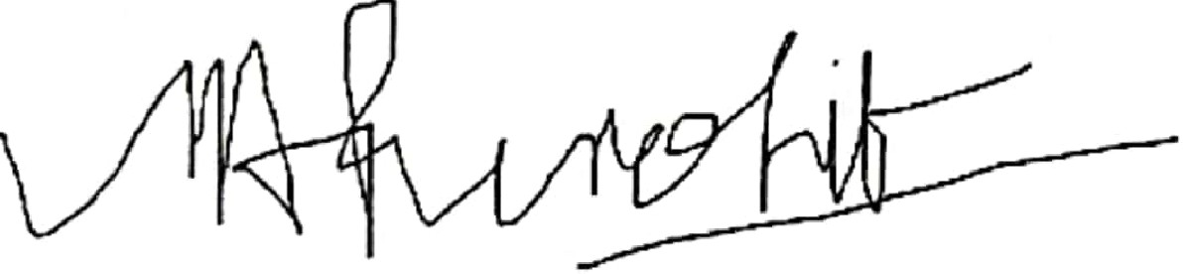

Electronically Signed by: MANISHA A PUROHIT MD

PG Z Bl•tti. Prnlhvusti· /ID. 48571 l DOG. 1011 2 11989

canned wnn cam canner